**HALL TICKET : 2403a51292**

**ASSIGNMENT : 7.1**

**BATCH : 12**

**TASK:1**

**Prompt:**  
The following Python code contains a syntax error due to a missing parenthesis in the print statement.

1. Use AI to detect and fix the syntax error.
2. Add at least 3 assert test cases to confirm the corrected code works.
3. Provide the corrected code and a brief explanation of the fix.

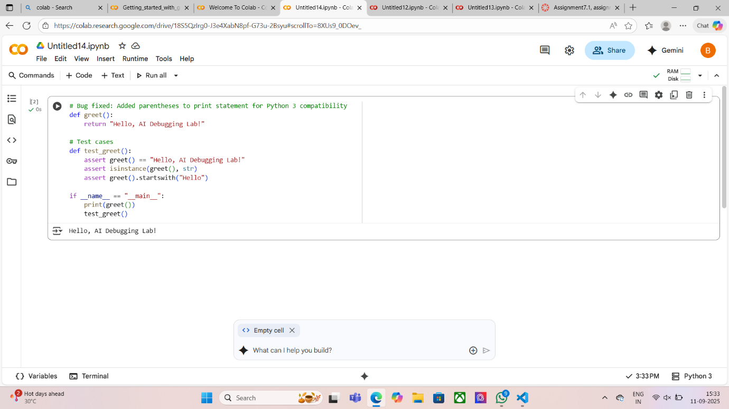

**TASK : 2**

**Prompt :**

The following Python code attempts to open a file that may not exist, which can cause the program to crash if the file is missing

1 vulnerability

1. Use AI to identify and explain the error.
2. Correct the code by implementing safe error handling (e.g., using a try-except block).
3. Add a user-friendly error message for missing or invalid files.
4. Test the function with at least 3 scenarios: file exists, file missing, and invalid path.

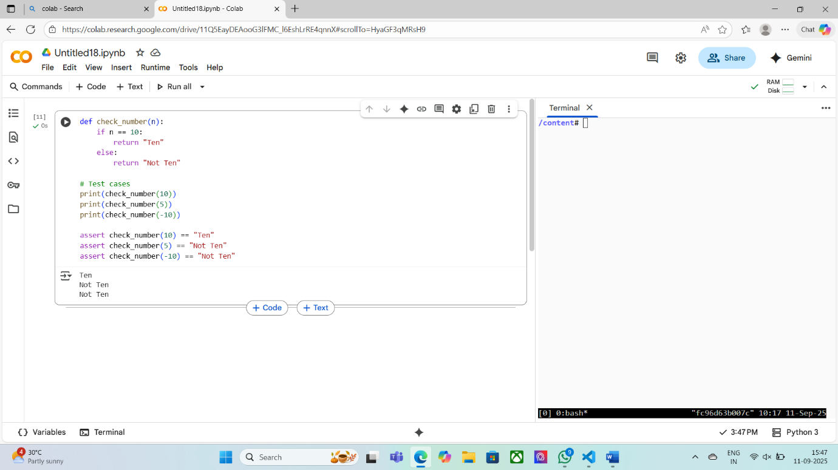

**TASK : 3**

**Prompt:**  
The following Python code attempts to call a method that does not exist in the class, resulting in an AttributeError.

1. Use AI to identify and explain the error.
2. Correct the code by either defining the missing method or correcting the method call.
3. Add at least 3 assert test cases to confirm the corrected class works as expected.
4. Provide the corrected code, test cases, and a brief explanation of the fix.

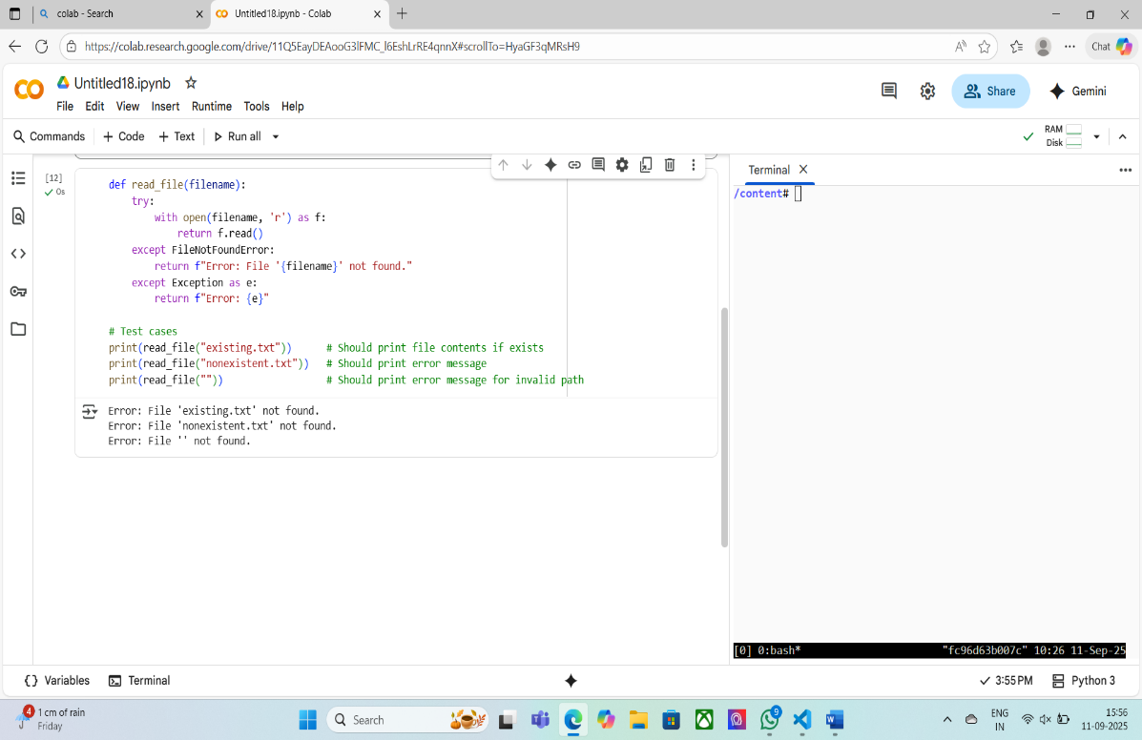

**TASK : 4**

**PROMPT :**

The following Python code attempts to call a method that does not exist in the class, resulting in an AttributeError.

1. Use AI to identify and explain the error.
2. Correct the code by either defining the missing method or correcting the method call.
3. Add at least 3 assert test cases to confirm the corrected class works as expected.
4. Provide the corrected code, test cases, and a brief explanation of the fix.

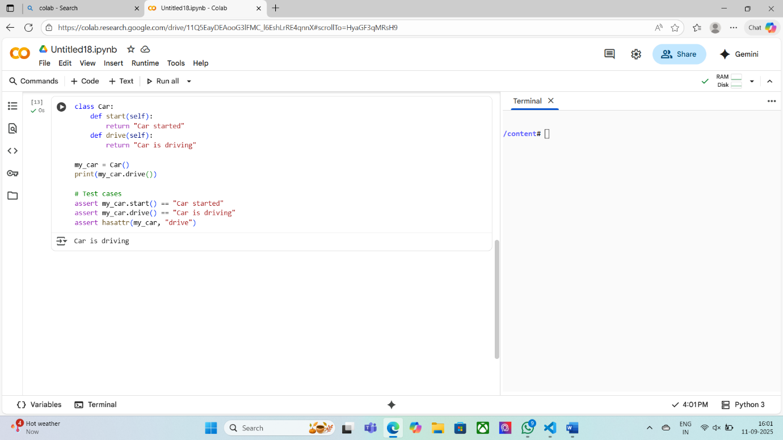

**TASK : 5**

**Prompt:**  
The following Python code attempts to add a string and an integer, which causes a TypeError.

1. Use AI to identify and explain the error.
2. Provide two solutions:
   * One using type casting (convert the string to an integer before addition).
   * One using string concatenation (convert the integer to a string before concatenation).
3. Add at least 3 assert test cases for each solution to confirm the corrected code works for multiple inputs.
4. Provide the corrected code, test cases, and a brief explanation of each fix.

